**Practical - 0**

Aim: Installation of QGIS software

Step 1: Right click on the .exe file and select Run as Administer.

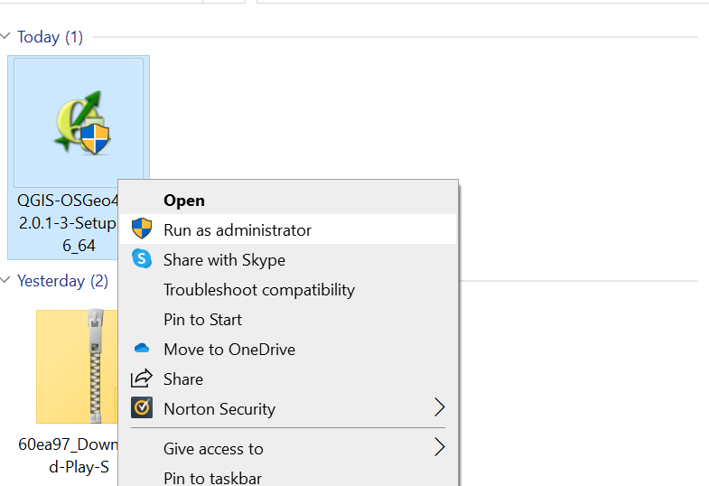

Step 2: Click Next

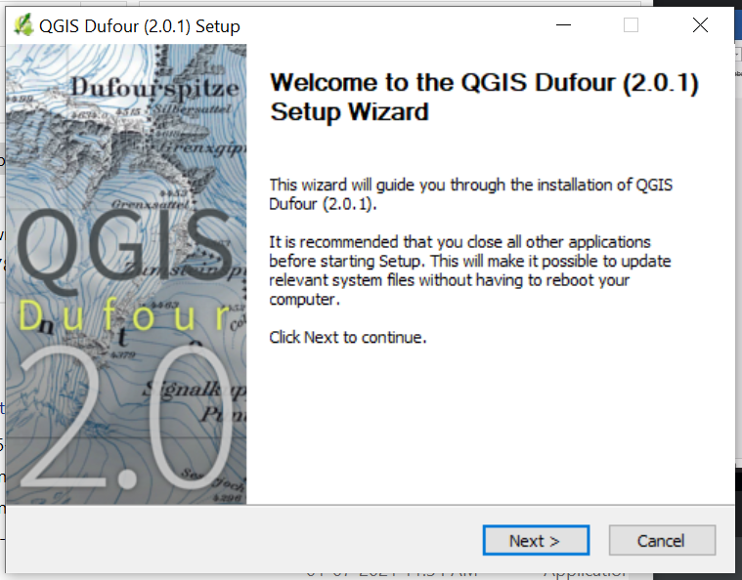

Step 3: Click on “I Agree”

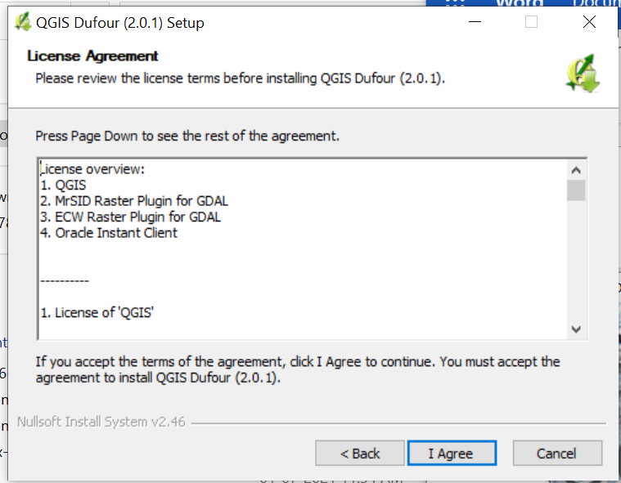

Step 4: Keep as it is or change the path according to your choice and select Next

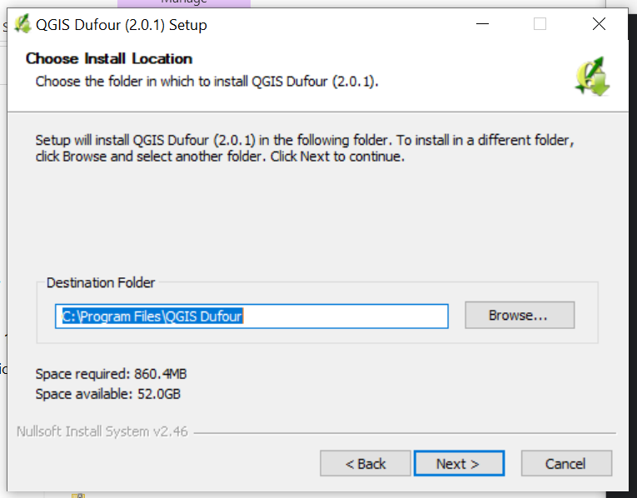

Step 5: Select as it is (default QGIS) and click Install

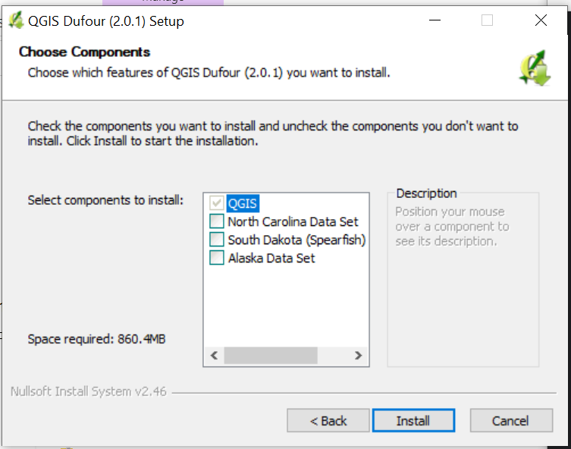

Step 6: Wait for the installation

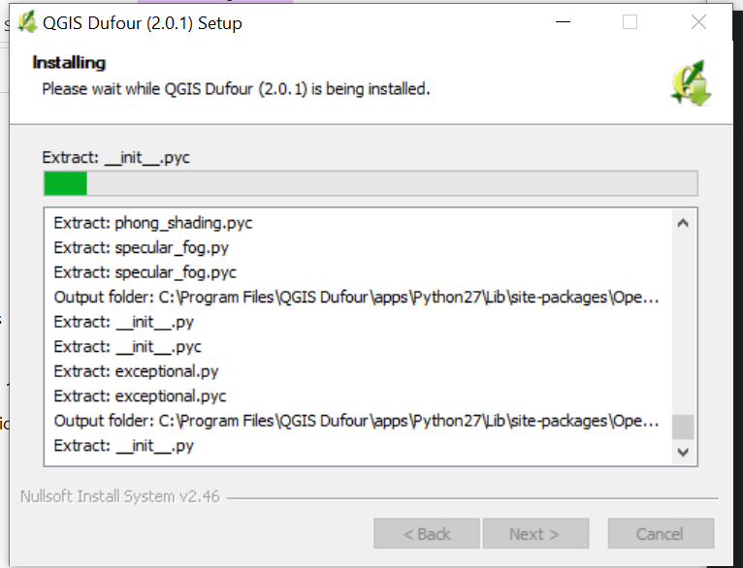

Step 7: Click Finish

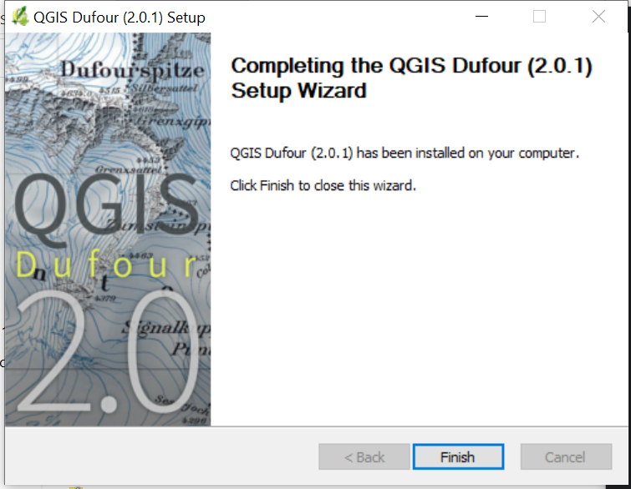

Step 8: On the desktop screen Click QGIS Desktop 2.0.1 icon

